**Running web application in virtual machine.**

The following are the steps to run the web program in virtual machine.

* In the terminal of vm, type the below commands to get the packages, to run the web program in ubuntu.

1. apt-get update

2. apt-get upgrade

3. apt-get install apache2

* Then give the command as **cd/var/www** and **cd/var/www/html** after that
* Open the gedit and type the web program.
* Then in Mozilla, type the **local host /filename.html**
* We get the output in the browser.
* From the host system, access the web application.(192.168.164.128/filename.html)

Simple web program

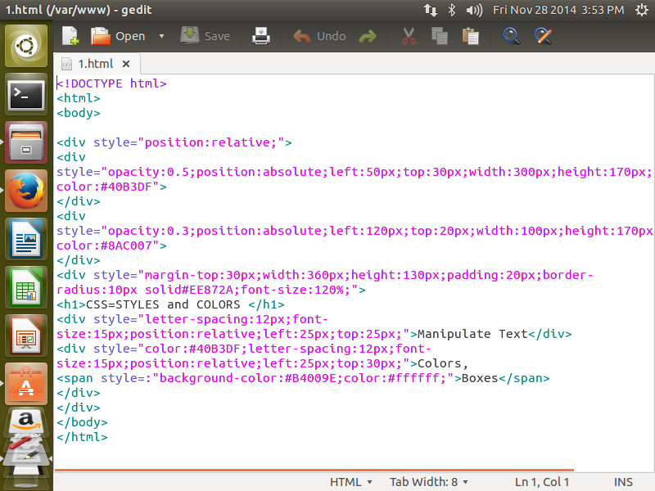

Output of the program

